**Successfully Node Js connected with MongoDB**

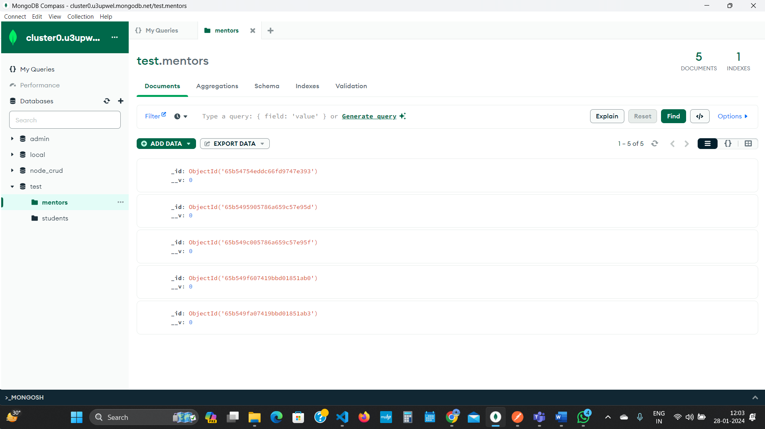

1)Write API to create Mentor

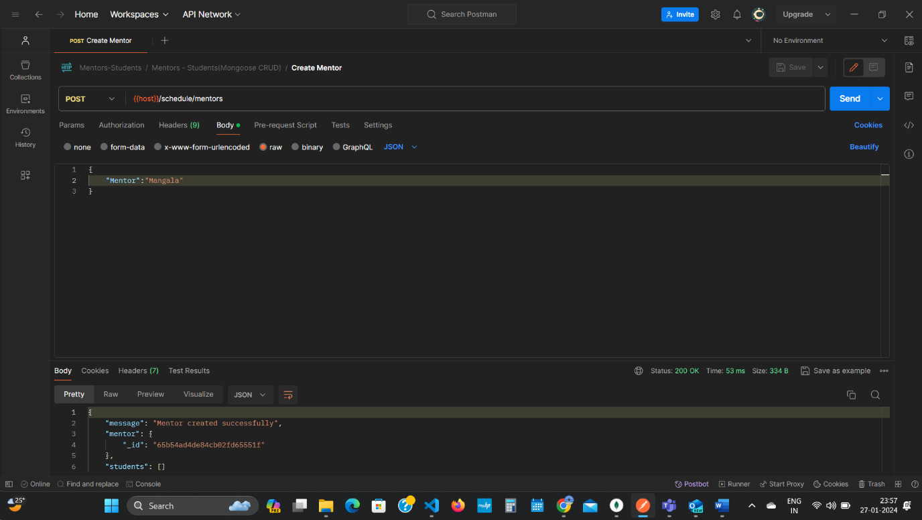

2) Write API to create Student

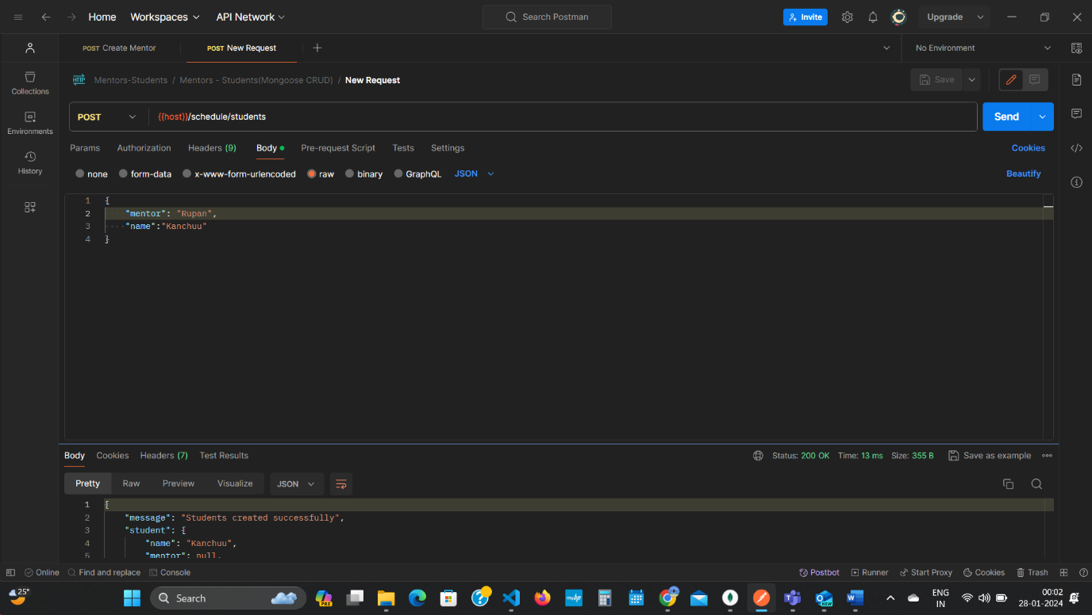  
  
  
3) Write API to Assign a student to Mentor

* Select one mentor and Add multiple Student
* A student who has a mentor should not be shown in List

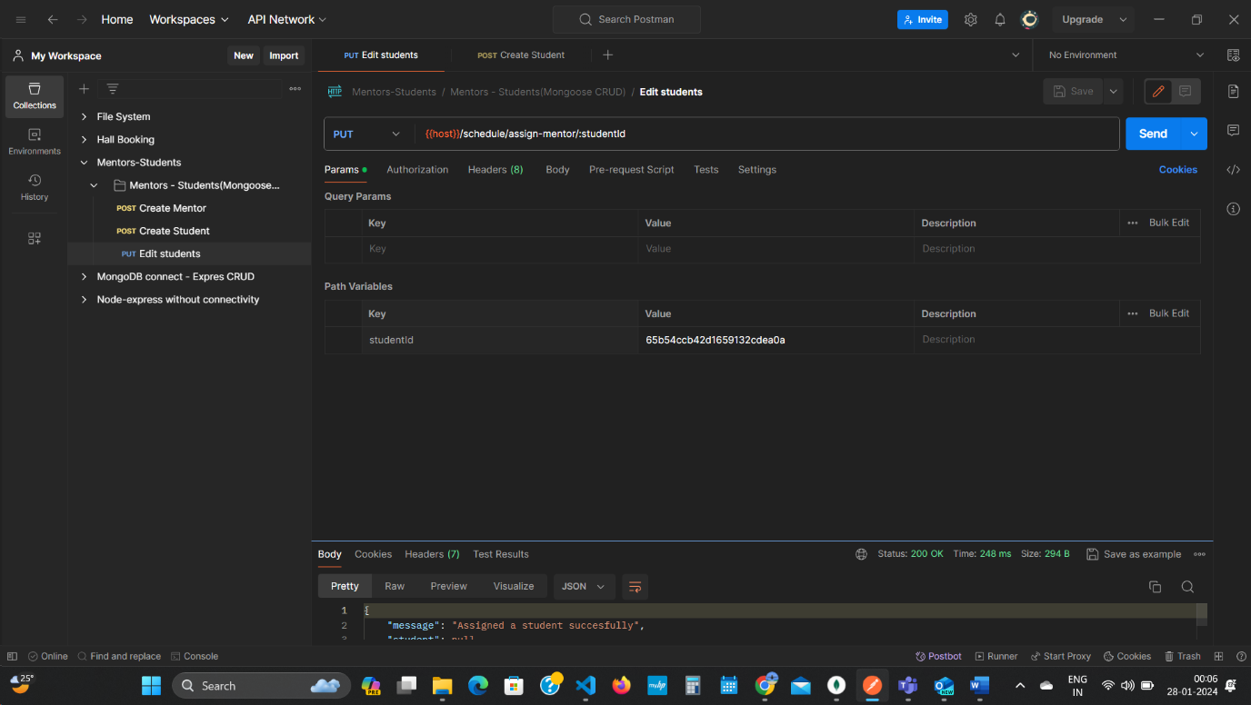

4)Write API to Assign or Change Mentor for particular Student

Select One Student and Assign one Mentor

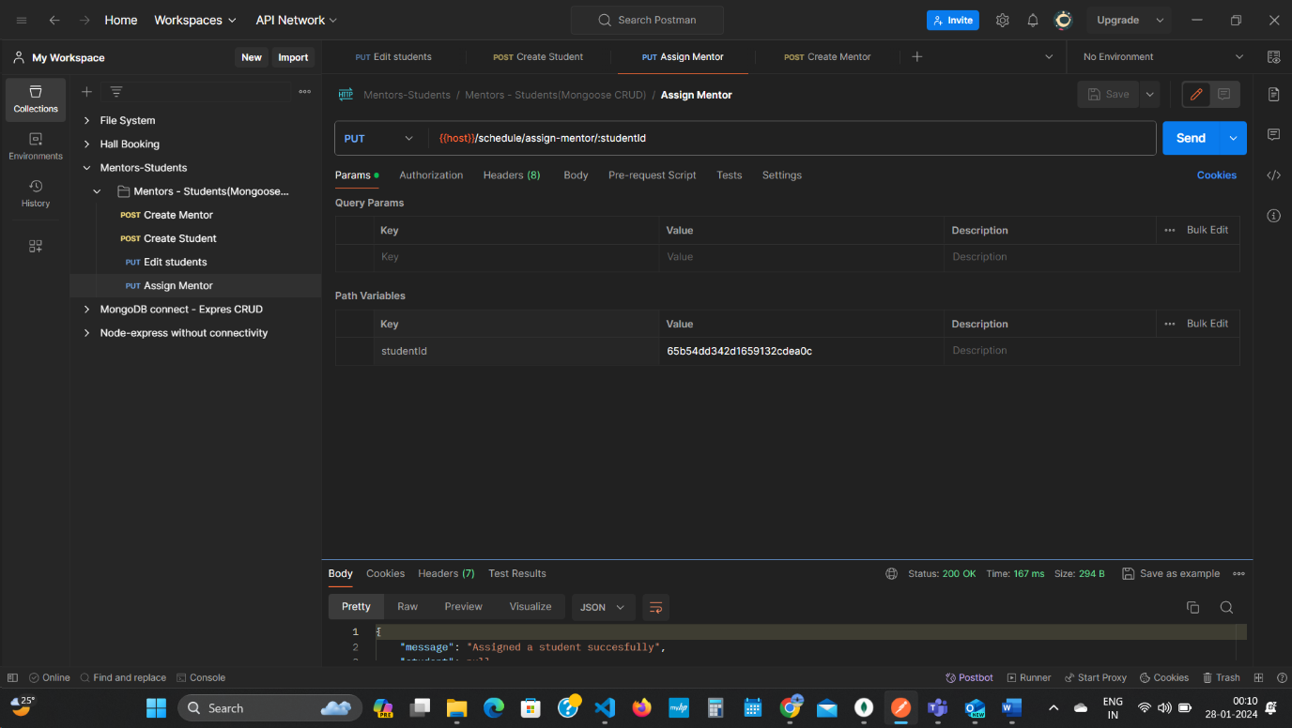

5)Write API to show all students for a particular mentor

